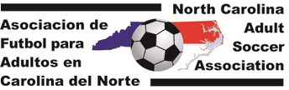

2016 NC ADULT SOCCER CUP
Date: December 3-4, 2016  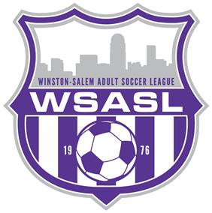  Location: BB&T Soccer Park, 428 Twins Way, Bermuda Run, NC 27006 (Winston-Salem, NC)  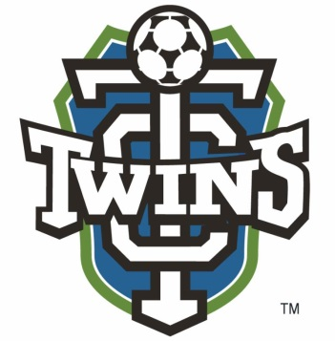  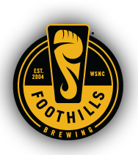  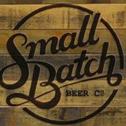  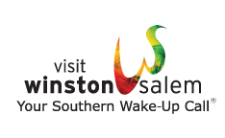  http://www.twincitysoccer.com/ | Newsletter Date: June 3, 2016
This year’s Adult Soccer Cup is going to be new and exciting. We have a brand new location, BB&T Soccer Park. We will be offering day and night games. The complex will be used solely for the NC Adult soccer community.

We are excited to announce that we will be having food trucks both Saturday and Sunday and a beer garden. Small Batch Beer Co. and Foothills Brewery are just two of the participating breweries so far. We are hoping to have a player social on Friday night at one of the breweries. NCASA Competitions Committee is working on the details to make this year’s NC Adult Soccer Cup the best so far.

We will have more information monthly, plus applications will be available by the end of June 2016.

Look for additional information in our monthly newsletter, at http://www.ncasasoccer.org, and at our facebook page, Women of North Carolina Adult Soccer.

